**Practical no.-**10

**Title:** Develop a webpage for creating session and persistent cookies.

**Roll No.:** **Batch-** A **Date of Performance:** 03/09/2023

**Code-**

<!DOCTYPE html>

<html>

<head>

<title>Session Cookie Example</title>

</head>

<body>

<h1>Session Cookie Example</h1>

<button onclick="createSessionCookie()">Create Session Cookie</button>

<div id="cookieData"></div>

<script>

function createSessionCookie() {

document.cookie = `sessionData=This is a session cookie ${new Date()}; path=/`;

alert("Session cookie created!");

readSessionCookie();

}

function readSessionCookie() {

var cookies = document.cookie.split(';');

var sessionData = null;

for (var i = 0; i < cookies. length; i++) {

var cookie = cookies[i].trim();

if (cookie.startsWith("sessionData=")) {

sessionData = cookie.substring("sessionData=".length);

break;

}

}

if (sessionData)

document.getElementById("cookieData").textContent = "Session Cookie Data: " + sessionData;

else

document.getElementById("cookieData").textContent = "Session cookie not found.";

}

readSessionCookie();

</script>

</body>

</html>

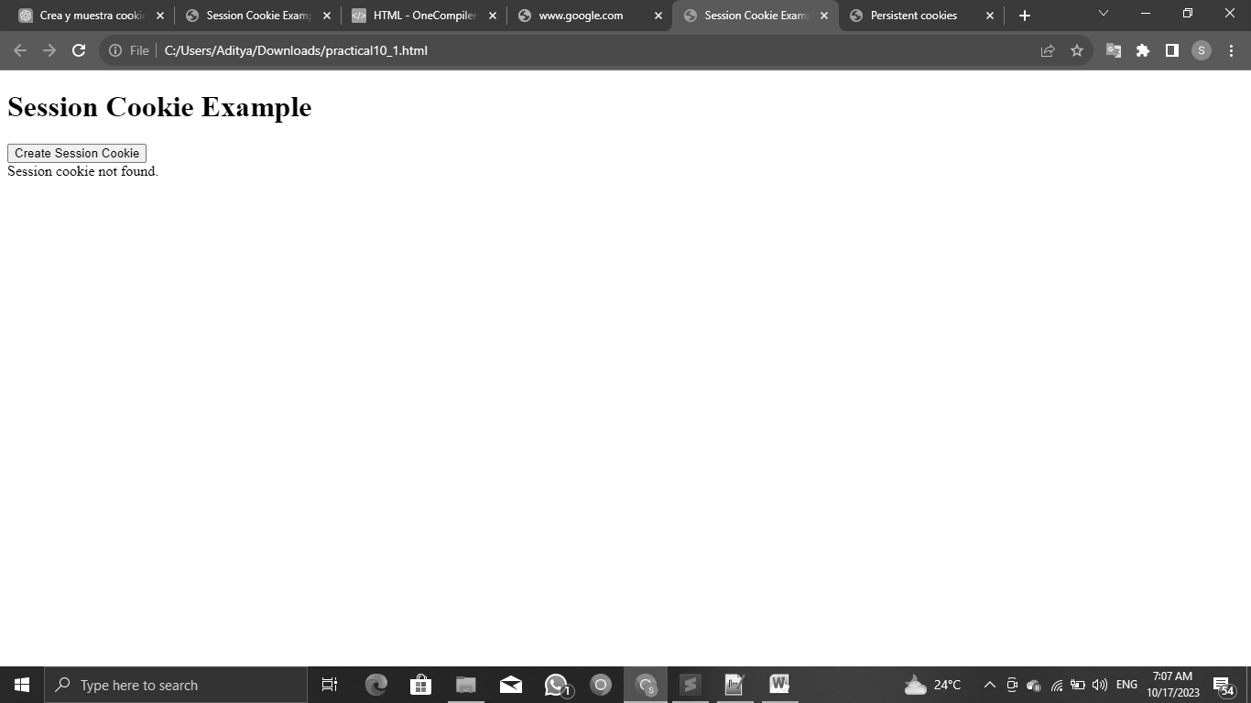**Output-**

<!DOCTYPE html>

<html>

<head>

<title>Persistent cookies</title>

</head>

<body>

<input type="text" id="getName" placeholder="Enter your name">

<br><br>

<button onclick="createCookieee()" id="crateCookieeBtn">Create Cookie</button>

<br><br>

<div id="cookieData"></div>

</body>

<script>

function createCookieee() {

let userName = document.getElementById("getName").value;

let date = new Date();

document.cookie = "userName=" + userName + ";" + "expires=" + date + 7 + ";";

document.cookie = "time=" + date + ";" + "expires=" + date + 7 + ";";

alert("Cookie Created successfully");

readCookieee();

}

function readCookieee() {

let testText = document.getElementById("cookieData");

let cookies = document.cookie.split(";");

for (let i = 0; i < cookies.length; i++) {

let cookiee = cookies[i].trim();

if (cookiee.indexOf("userName=") === 0 || cookiee.indexOf("time=") === 0) {

testText.textContent += cookiee.split("=")[1] + "\n";

}

}

}

</script>

</html>

**OUTPUT-**

